U25AI055
Lab-3
Experiment 1: Design a Fully-Featured Singly Linked List ADT
// 1: Design a fully featured singly linked list ADT
#include <stdio.h>
#include <stdlib.h>
struct Node
{
int data;
struct Node *next;
};
struct Node *insertAtHead(struct Node *head, int element);
struct Node *insertAtTail(struct Node *head, int element);
struct Node *deleteByValue(struct Node *head, int element);
struct Node *deleteByPosition(struct Node *head, int position);
struct Node *searchForValue(struct Node *head, int element);
struct Node *reverseList(struct Node *head);
void displayList(struct Node *head);
int detectCycle(struct Node *head);
int main()
{
int n, i, choice, element, position;
struct Node *head, *newNode, *temp;
printf("Enter number of nodes: ");
scanf("%d", &n);
if (n == 0)
{
head = NULL;
}
else
{
newNode = (struct Node*)malloc(sizeof(struct Node));
printf("Enter element 1: ");
scanf("%d", &newNode->data);
newNode->next = NULL;
head = newNode;
temp = newNode;
for (i = 2; i <= n; i++)
{
newNode = (struct Node*)malloc(sizeof(struct Node));
printf("Enter element %d: ", i);
scanf("%d", &newNode->data);
newNode->next = NULL;
temp->next = newNode;
temp = temp->next;
}
}
do
{
printf("1: Insert at head\n");
printf("2: Insert at tail\n");
printf("3: Delete by value\n");
printf("4: Delete by position\n");
printf("5: Search for value\n");
printf("6: Reverse list\n");
printf("7: Display list\n");
printf("8: Detect cycle\n");
printf("Enter choice: ");
scanf("%d", &choice);
switch (choice)
{
case 1:
printf("Enter element: ");
scanf("%d", &element);
head = insertAtHead(head, element);
break;
case 2:
printf("Enter element: ");
scanf("%d", &element);
head = insertAtTail(head, element);
break;
case 3:
printf("Enter element: ");
scanf("%d", &element);
head = deleteByValue(head, element);
break;
case 4:
printf("Enter position: ");
scanf("%d", &position);
head = deleteByPosition(head, position);
break;
case 5:
printf("Enter element: ");
scanf("%d", &element);
printf("Element found at %u", searchForValue(head, element));
break;
case 6:
head = reverseList(head);
break;
case 7:
printf("Elements of list are ");
displayList(head);
printf("\n");
break;
case 8:
if (detectCycle(head))
{
printf("Linked list is cyclic\n");
}
else
{
printf("Linked list is not cyclic\n");
}
break;
default:
printf("Invalid choice\n");
}
} while (choice >= 1 && choice <= 8);
return 0;
}
struct Node *insertAtHead(struct Node *head, int element)
{
struct Node *newNode;
newNode = (struct Node*)malloc(sizeof(struct Node));
newNode->data = element;
newNode->next = head;
head = newNode;
return head;
}
struct Node *insertAtTail(struct Node *head, int element)
{
struct Node *newNode, *ptr;
newNode = (struct Node*)malloc(sizeof(struct Node));
newNode->data = element;
newNode->next = NULL;
ptr = head;
if (head == NULL)
{
head = newNode;
return head;
}
else
{
while (ptr->next != NULL)
{
ptr = ptr->next;
}
ptr->next = newNode;
return head;
}
}
struct Node *deleteByValue(struct Node *head, int element)
{
if (head == NULL)
{
return NULL;
}
struct Node *fast, *slow;
slow = fast = head;
while (fast->data != element && fast->next != NULL)
{
slow = fast;
fast = fast->next;
}
if (slow == fast)
{
head = fast->next;
free(fast);
}
if (fast->data == element)
{
slow->next = fast->next;
free(fast);
}
return head;
}
struct Node *deleteByPosition(struct Node *head, int position)
{
if (head == NULL)
{
return NULL;
}
int i;
struct Node *fast, *slow;
slow = fast = head;
for (i = 0; i < position && fast->next != NULL; i++)
{
slow = fast;
fast = fast->next;
}
if (slow == fast)
{
head = fast->next;
free(fast);
return head;
}
if (i == position)
{
slow->next = fast->next;
free(fast);
return head;
}
}
struct Node *searchForValue(struct Node *head, int element)
{
if (head == NULL)
{
return NULL;
}
struct Node *ptr;
ptr = head;
while (ptr->data != element && ptr->next != NULL)
{
ptr = ptr->next;
}
if (ptr->data == element)
{
return ptr;
}
}
struct Node *reverseList(struct Node *head)
{
struct Node *ptr, *fast, *slow;
ptr = head;
slow = fast = NULL;
while (ptr != NULL)
{
fast = ptr;
ptr = ptr->next;
fast->next = slow;
slow = fast;
}
head = fast;
return head;
}
void displayList(struct Node *head)
{
struct Node *ptr;
ptr = head;
while (ptr != NULL)
{
printf("%d\t", ptr->data);
ptr = ptr->next;
}
}
int detectCycle(struct Node *head)
{
struct Node *fast, *slow;
slow = fast = head;
while (fast != NULL && fast->next != NULL)
{
slow = slow->next;
fast = (fast->next)->next;
if (slow == fast)
{
return 1;
}
}
return 0;
}
Output:
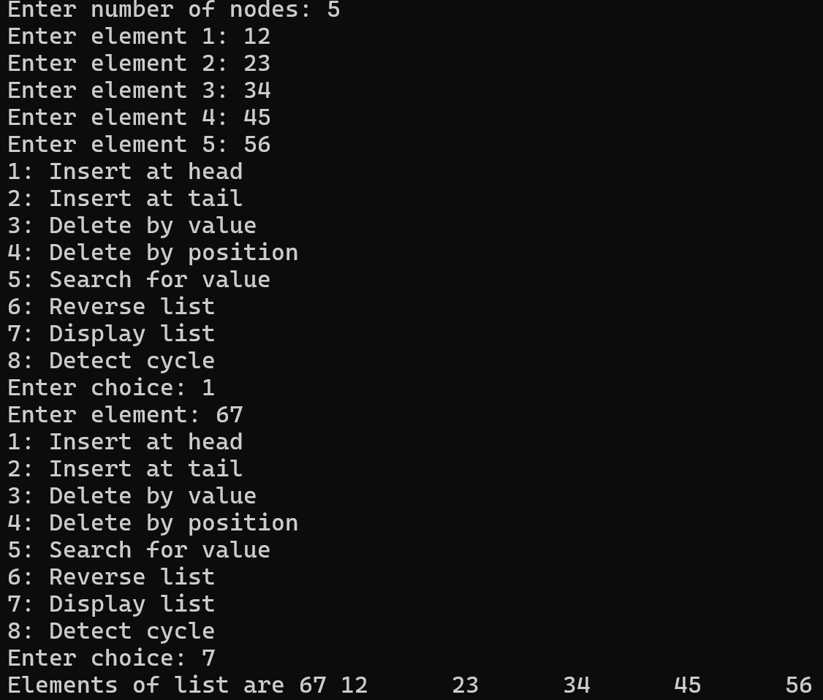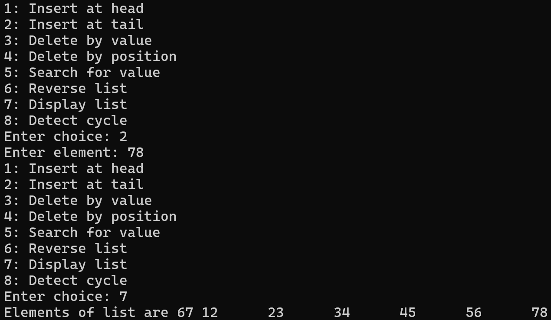
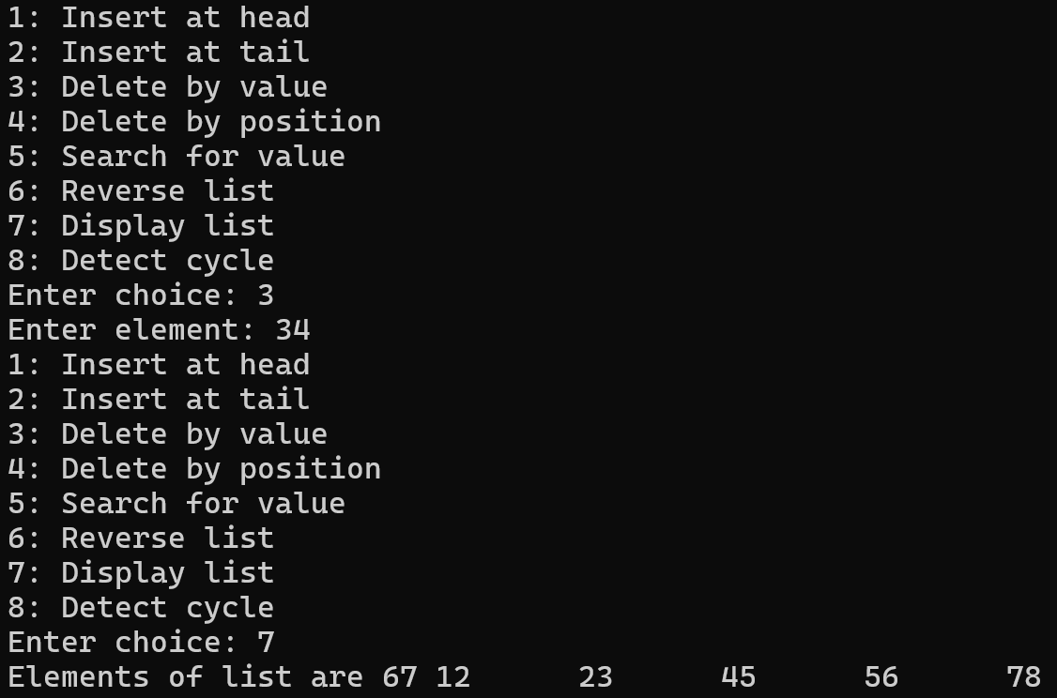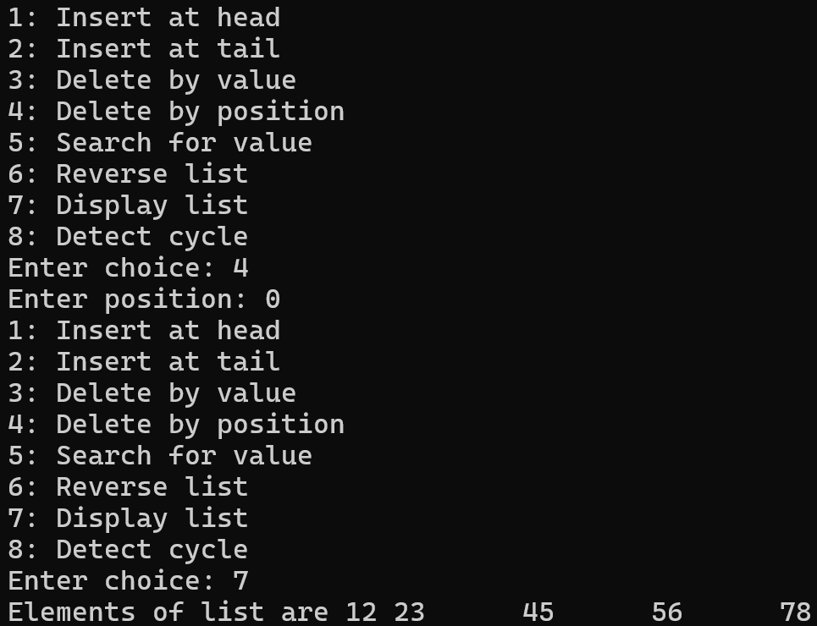
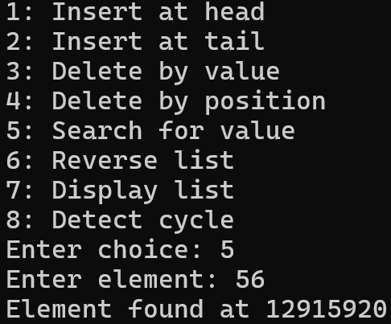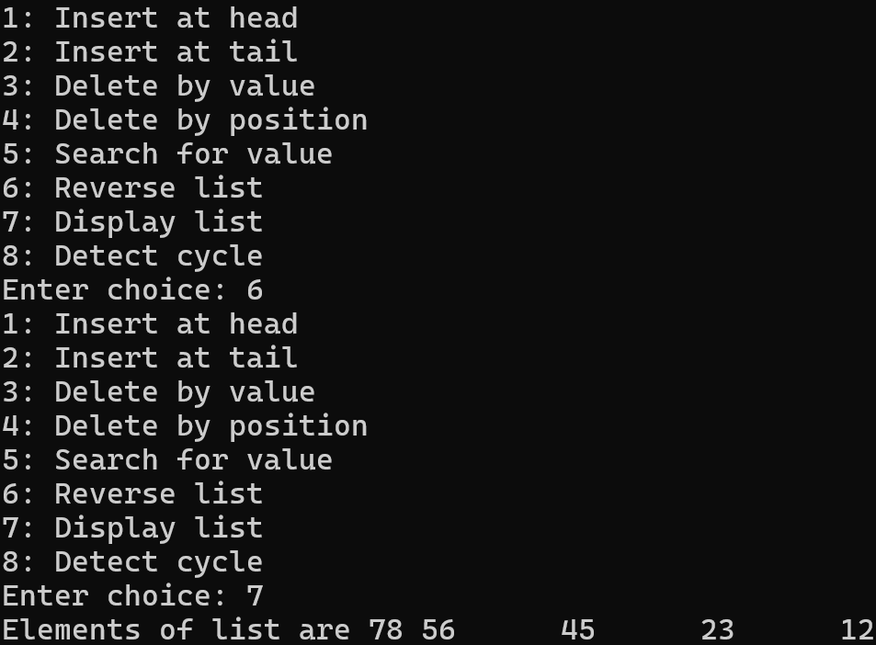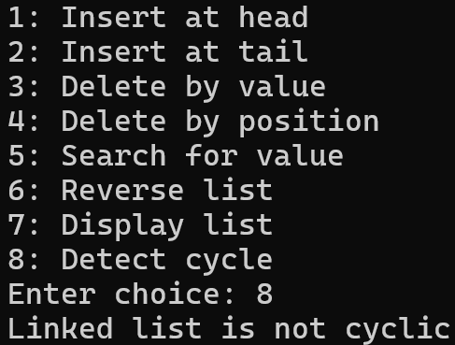
Experiment 2: Insert at Beginning with Undo Capability
// 2: Insert at beginning with undo capability
#include <stdio.h>
#include <stdlib.h>
struct Node
{
int data;
struct Node *next;
};
struct Node *insertAtBeginning(struct Node *head, int element);
struct Node *undo(const struct Node *originalHead, struct Node *head);
void displayList(struct Node *head);
int main()
{
int n, i, choice, element;
const struct Node *originalHead;
struct Node *head, *newNode, *temp;
printf("Enter number of nodes: ");
scanf("%d", &n);
if (n == 0)
{
originalHead = head = NULL;
}
else
{
newNode = (struct Node*)malloc(sizeof(struct Node));
printf("Enter element 1: ");
scanf("%d", &newNode->data);
newNode->next = NULL;
originalHead = head = newNode;
temp = newNode;
for (i = 2; i <= n; i++)
{
newNode = (struct Node*)malloc(sizeof(struct Node));
printf("Enter element %d: ", i);
scanf("%d", &newNode->data);
newNode->next = NULL;
temp->next = newNode;
temp = temp->next;
}
}
do
{
printf("1. Insert at beginning\n");
printf("2. Undo\n");
printf("3. Display list\n");
printf("Enter choice: ");
scanf("%d", &choice);
switch (choice)
{
case 1:
printf("Enter element: ");
scanf("%d", &element);
head = insertAtBeginning(head, element);
break;
case 2:
head = undo(originalHead, head);
break;
case 3:
printf("Elements of list are ");
displayList(head);
printf("\n");
break;
default:
printf("Invalid choice\n");
}
} while (choice >= 1 && choice <= 3);
return 0;
}
struct Node *insertAtBeginning(struct Node *head, int element)
{
struct Node *newNode;
newNode = (struct Node*)malloc(sizeof(struct Node));
newNode->data = element;
newNode->next = head;
head = newNode;
return head;
}
struct Node *undo(const struct Node *originalHead, struct Node *head)
{
if (originalHead == head)
{
return head;
}
else
{
struct Node *temp;
temp = head;
head = temp->next;
free(temp);
return head;
}
}
void displayList(struct Node *head)
{
struct Node *ptr;
ptr = head;
while (ptr != NULL)
{
printf("%d\t", ptr->data);
ptr = ptr->next;
}
}
Output:
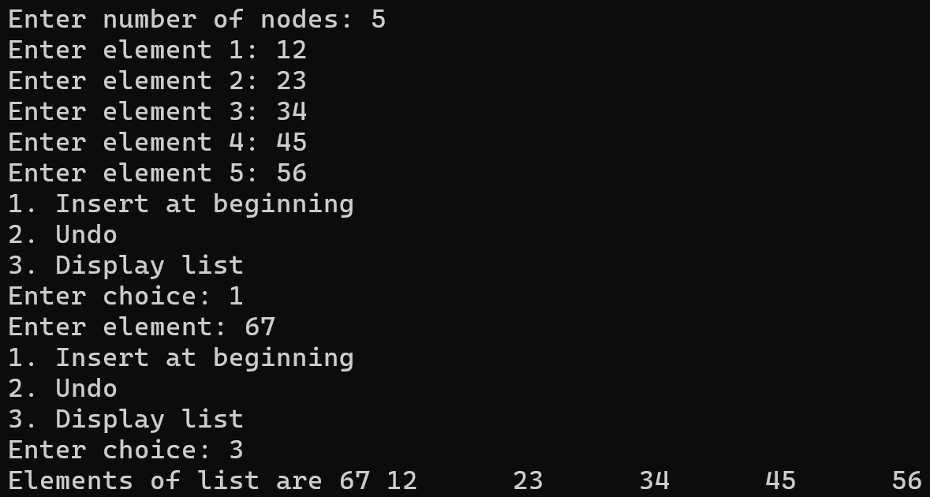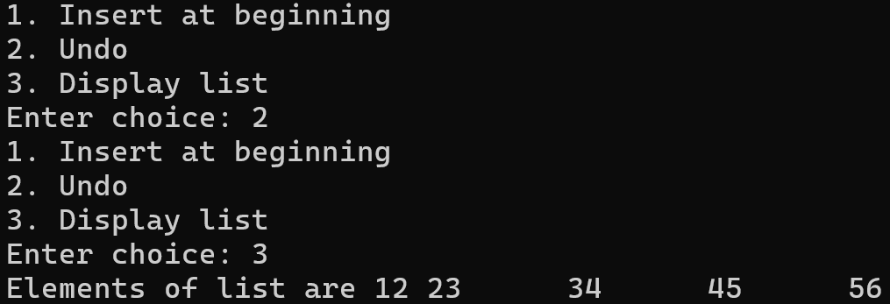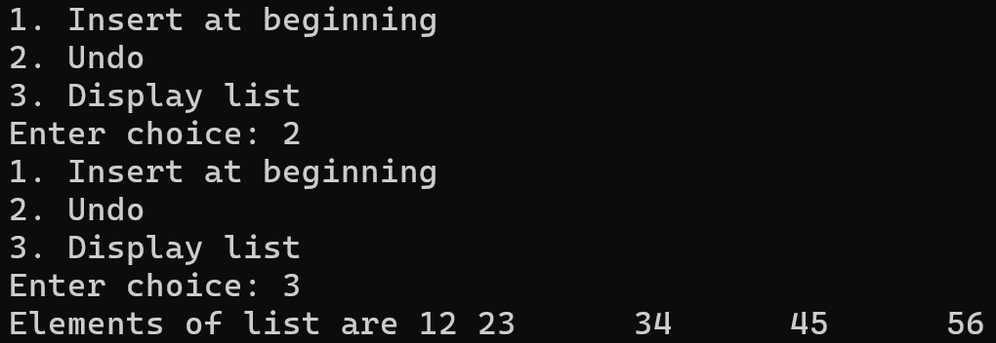
Experiment 3: Insert at End with Tail Optimization
// 3: Insert at end with tail optimisation
#include <stdio.h>
#include <stdlib.h>
struct Node
{
int data;
struct Node *next;
};
struct Node *insertAtEnd(struct Node *tail, int element);
void displayList(struct Node *head);
int main()
{
int n, i, choice, element;
struct Node *head, *tail, *newNode, *temp;
printf("Enter number of nodes: ");
scanf("%d", &n);
if (n == 0)
{
head = tail = NULL;
}
else
{
newNode = (struct Node*)malloc(sizeof(struct Node));
printf("Enter element 1: ");
scanf("%d", &newNode->data);
newNode->next = NULL;
head = tail = newNode;
temp = newNode;
for (i = 2; i <= n; i++)
{
newNode = (struct Node*)malloc(sizeof(struct Node));
printf("Enter element %d: ", i);
scanf("%d", &newNode->data);
newNode->next = NULL;
tail = newNode;
temp->next = newNode;
temp = temp->next;
}
}
do
{
printf("1: Insert at end\n");
printf("2: Display list\n");
printf("Enter choice: ");
scanf("%d", &choice);
switch (choice)
{
case 1:
printf("Enter element: ");
scanf("%d", &element);
tail = insertAtEnd(tail, element);
break;
case 2:
printf("Elements of list are ");
displayList(head);
printf("\n");
break;
default:
printf("Invalid choice\n");
}
} while (choice >= 1 && choice <= 2);
return 0;
}
struct Node *insertAtEnd(struct Node *tail, int element)
{
struct Node *newNode = (struct Node*)malloc(sizeof(struct Node));
newNode->data = element;
newNode->next = NULL;
tail->next = newNode;
tail = newNode;
return tail;
}
void displayList(struct Node *head)
{
struct Node *ptr;
ptr = head;
while (ptr != NULL)
{
printf("%d\t", ptr->data);
ptr = ptr->next;
}
}
Output:
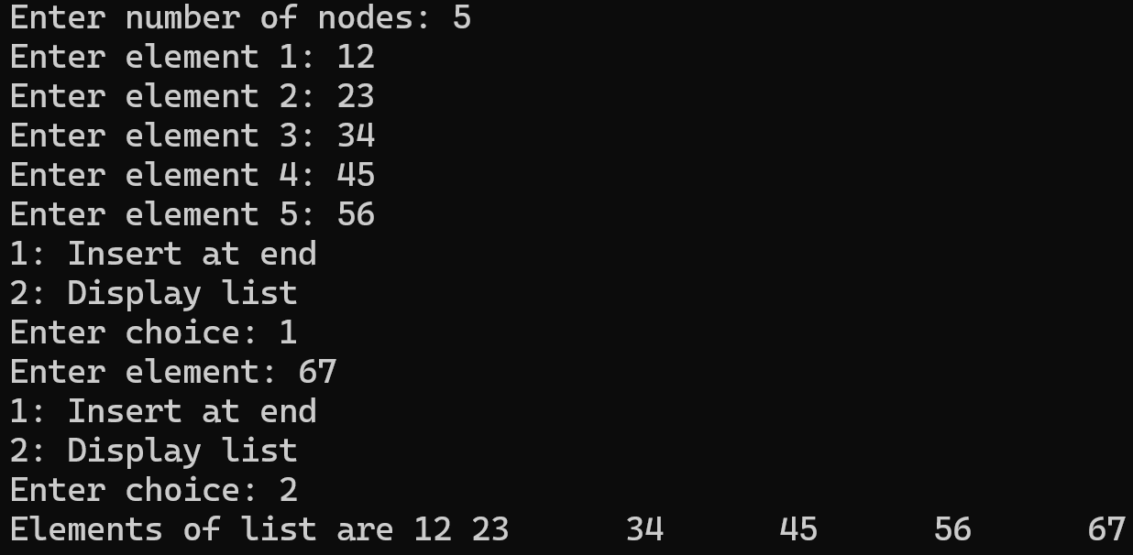
Experiment 4: Position-Based Insertion and Deletion
// 4: Position based insertion and deletion
#include <stdio.h>
#include <stdlib.h>
struct Node
{
int data;
struct Node *next;
};
struct Node *insertAtPosition(struct Node *head, int element, int position);
struct Node *deleteByPosition(struct Node *head, int position);
void displayList(struct Node *head);
int main()
{
int n, i, choice, element, position;
struct Node *head, *newNode, *temp;
printf("Enter number of nodes: ");
scanf("%d", &n);
if (n == 0)
{
head = NULL;
}
else
{
newNode = (struct Node*)malloc(sizeof(struct Node));
printf("Enter element 1: ");
scanf("%d", &newNode->data);
newNode->next = NULL;
head = newNode;
temp = newNode;
for (i = 2; i <= n; i++)
{
newNode = (struct Node*)malloc(sizeof(struct Node));
printf("Enter element %d: ", i);
scanf("%d", &newNode->data);
newNode->next = NULL;
temp->next = newNode;
temp = temp->next;
}
}
do
{
printf("1: Insert at position\n");
printf("2: Delete by position\n");
printf("3: Display list\n");
printf("Enter choice: ");
scanf("%d", &choice);
switch (choice)
{
case 1:
printf("Enter element: ");
scanf("%d", &element);
printf("Enter position: ");
scanf("%d", &position);
head = insertAtPosition(head, element, position);
break;
case 2:
printf("Enter position: ");
scanf("%d", &position);
head = deleteByPosition(head, position);
break;
case 3:
printf("Elements of linked list are ");
displayList(head);
printf("\n");
break;
default:
printf("Invalid choice\n");
}
} while (choice >= 1 && choice <= 8);
return 0;
}
struct Node *insertAtPosition(struct Node *head, int element, int position)
{
struct Node *newNode;
newNode = (struct Node*)malloc(sizeof(struct Node));
newNode->data = element;
int i;
struct Node *fast, *slow;
slow = fast = head;
for (i = 0; i < position && fast != NULL; i++)
{
slow = fast;
fast = fast->next;
}
if (slow == fast)
{
newNode->next = head;
head = newNode;
return head;
}
if (i == position)
{
slow->next = newNode;
newNode->next = fast;
}
return head;
}
struct Node *deleteByPosition(struct Node *head, int position)
{
if (head == NULL)
{
return NULL;
}
int i;
struct Node *fast, *slow;
slow = fast = head;
for (i = 0; i < position && fast->next != NULL; i++)
{
slow = fast;
fast = fast->next;
}
if (slow == fast)
{
head = fast->next;
free(fast);
return head;
}
if (i == position)
{
slow->next = fast->next;
free(fast);
}
return head;
}
void displayList(struct Node *head)
{
struct Node *ptr;
ptr = head;
while (ptr != NULL)
{
printf("%d\t", ptr->data);
ptr = ptr->next;
}
}
Output:
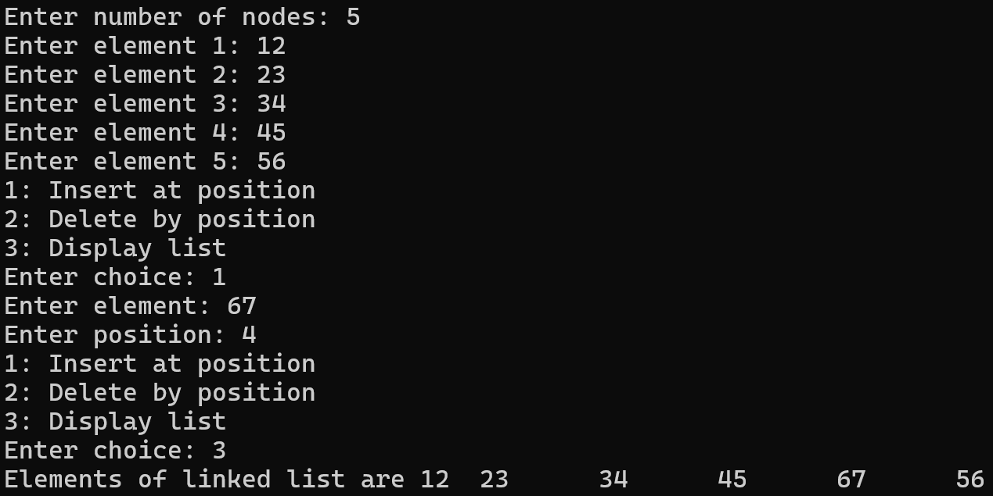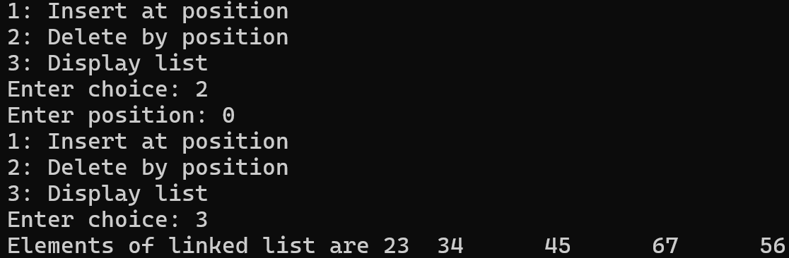
Experiment 5: Delete Nth Node from End (One Pass Only)
// 5: Delete nth node from end in one pass only
#include <stdio.h>
#include <stdlib.h>
struct Node
{
int data;
struct Node *next;
};
struct Node *deleteNthNodeFromEnd(struct Node *head, int n);
void displayList(struct Node *head);
int main()
{
int n, i, choice, k;
struct Node *head, *newNode, *temp;
printf("Enter number of nodes: ");
scanf("%d", &n);
if (n == 0)
{
head = NULL;
}
else
{
newNode = (struct Node*)malloc(sizeof(struct Node));
printf("Enter element 1: ");
scanf("%d", &newNode->data);
newNode->next = NULL;
head = newNode;
temp = newNode;
for (i = 2; i <= n; i++)
{
newNode = (struct Node*)malloc(sizeof(struct Node));
printf("Enter element %d: ", i);
scanf("%d", &newNode->data);
newNode->next = NULL;
temp->next = newNode;
temp = temp->next;
}
}
do
{
printf("1: Delete nth node from end\n");
printf("2: Display list\n");
printf("Enter choice: ");
scanf("%d", &choice);
switch (choice)
{
case 1:
printf("Enter position of node from end: ");
scanf("%d", &k);
head = deleteNthNodeFromEnd(head, k);
break;
case 2:
printf("Elements of list are ");
displayList(head);
printf("\n");
break;
default:
printf("Invalid choice\n");
}
} while (choice >= 1 && choice <= 2);
return 0;
}
struct Node *deleteNthNodeFromEnd(struct Node *head, int n)
{
struct Node *p, *q, *r;
r = q = p = head;
while (p->next != NULL && n != 0)
{
n--; // 3-1, 2-2, 1-3, 0-4
p = p->next;
}
while (p->next != NULL && p != NULL)
{
r = q;
q = q->next;
p = p->next;
}
if (r == q)
{
head = q->next;
free(q);
}
else
{
r->next = q->next;
free(q);
}
return head;
}
void displayList(struct Node *head)
{
struct Node *ptr;
ptr = head;
while (ptr != NULL)
{
printf("%d\t", ptr->data);
ptr = ptr->next;
}
}
Output:
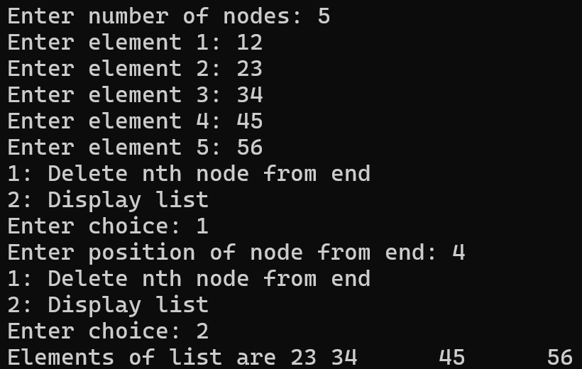
Experiment 6: Detect and Remove Cycle
// 6: Detect and remove cycle
#include <stdio.h>
#include <stdlib.h>
struct Node
{
int data;
struct Node *next;
};
int detectCycle(struct Node *head);
struct Node *detectCycleStart(struct Node *head);
void removeCycle(struct Node *head);
void displayList(struct Node *head);
int main()
{
int n, i, choice;
struct Node *head, *node1, *node2, *node3, *node4, *node5;
node1 = (struct Node*)malloc(sizeof(struct Node));
node2 = (struct Node*)malloc(sizeof(struct Node));
node3 = (struct Node*)malloc(sizeof(struct Node));
node4 = (struct Node*)malloc(sizeof(struct Node));
node5 = (struct Node*)malloc(sizeof(struct Node));
node1->data = 1;
node1->next = node2;
head = node1;
node2->data = 2;
node2->next = node3;
node3->data = 3;
node3->next = node4;
node4->data = 4;
node4->next = node5;
node5->data = 5;
node5->next = node3;
do
{
printf("1: Detect cycle\n");
printf("2: Remove cycle\n");
printf("Enter choice: ");
scanf("%d", &choice);
switch (choice)
{
case 1:
if (detectCycle(head))
{
printf("Linked list is cyclic\n");
}
else
{
printf("Linked list is not cyclic\n");
}
break;
case 2:
removeCycle(head);
break;
default:
printf("Invalid choice\n");
}
} while (choice >= 1 && choice <= 2);
return 0;
}
int detectCycle(struct Node *head)
{
struct Node *slow, *fast;
slow = fast = head;
while (fast != NULL && fast->next != NULL)
{
slow = slow->next;
fast = (fast->next)->next;
if (slow == fast)
{
return 1;
}
}
return 0;
}
struct Node *detectCycleStart(struct Node *head)
{
struct Node *slow, *fast;
slow = fast = head;
while (fast != NULL && fast->next != NULL)
{
slow = slow->next;
fast = (fast->next)->next;
if (slow == fast)
{
slow = head;
while (slow != fast)
{
slow = slow->next;
fast = fast->next;
}
return slow;
}
}
return NULL;
}
void removeCycle(struct Node *head)
{
struct Node *ptr, *start;
ptr = head;
start = detectCycleStart(head);
if (start == NULL)
{
return;
}
while (ptr->next != start)
{
ptr = ptr->next;
}
ptr->next = NULL;
}
void displayList(struct Node *head)
{
struct Node *ptr;
ptr = head;
while (ptr != NULL)
{
printf("%d\t", ptr->data);
ptr = ptr->next;
}
}
Output:
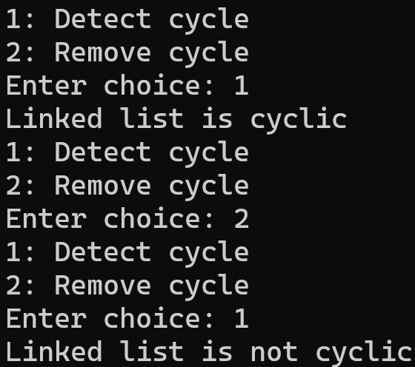
Experiment 7: Reverse Linked List in Groups of K
// 7: Reverse linked list in groups of k
#include <stdio.h>
#include <stdlib.h>
struct Node
{
int data;
struct Node *next;
};
struct Node *reverseListInGroups(struct Node *head, int k);
void displayList(struct Node *head);
int main()
{
int n, i, k;
struct Node *head, *newNode, *temp;
printf("Enter number of nodes: ");
scanf("%d", &n);
if (n == 0)
{
head = NULL;
}
else
{
newNode = (struct Node*)malloc(sizeof(struct Node));
printf("Enter element 1: ");
scanf("%d", &newNode->data);
newNode->next = NULL;
head = newNode;
temp = newNode;
for (i = 2; i <= n; i++)
{
newNode = (struct Node*)malloc(sizeof(struct Node));
printf("Enter element %d: ", i);
scanf("%d", &newNode->data);
newNode->next = NULL;
temp->next = newNode;
temp = temp->next;
}
}
printf("Elements of linked list are ");
displayList(head);
printf("\n");
printf("Enter number of nodes in group: ");
scanf("%d", &k);
head = reverseListInGroups(head, k);
printf("Elements of linked list are ");
displayList(head);
printf("\n");
return 0;
}
struct Node *reverseListInGroups(struct Node *head, int k)
{
int count;
struct Node *ptr, *fast, *slow, *rev, *end, *temp;
ptr = head;
slow = fast = NULL;
count = k;
while (ptr != NULL && count != 0)
{
count--;
fast = ptr;
ptr = ptr->next;
fast->next = slow;
slow = fast;
}
rev = fast;
while (ptr != NULL)
{
end = rev;
while (end->next != NULL)
{
end = end->next;
}
slow = fast = NULL;
count = k;
while (ptr != NULL && count != 0)
{
count--;
fast = ptr;
ptr = ptr->next;
fast->next = slow;
slow = fast;
}
temp = fast;
if (count != 0)
{
ptr = fast;
slow = fast = NULL;
while (ptr != NULL)
{
fast = ptr;
ptr = ptr->next;
fast->next = slow;
slow = fast;
}
temp = fast;
}
end->next = temp;
}
return rev;
}
void displayList(struct Node *head)
{
struct Node *ptr;
ptr = head;
while (ptr != NULL)
{
printf("%d\t", ptr->data);
ptr = ptr->next;
}
}
Output:
